|  |  |  |  |  |  |
| --- | --- | --- | --- | --- | --- |
| **Key Vocabulary** | | | | | |
| **Warm-up**  Importance Of Warming Up And Cooling Down - UltraCare Pro | **Cool down** | | **Catching**  Catch Picture for Classroom / Therapy Use - Great Catch Clipart | Catch, Clip  art, Picture | | **Galloping** |
| **What you need to be successful?** | | | | | |
| **Jumping** | | **Balancing** | | **Throwing** | |
| * Be light on our feet. * Head up. * Eyes looking forward. * Arms driving to push us forwards. | | * Keep your head upright. * Hold your arms out. * Focus on a still object. | | * Stand at one side. * Eyes looking forward. * Move your arm backwards and then forwards quickly. * Let go | |
| **Building Blocks to Success** | | | | | |

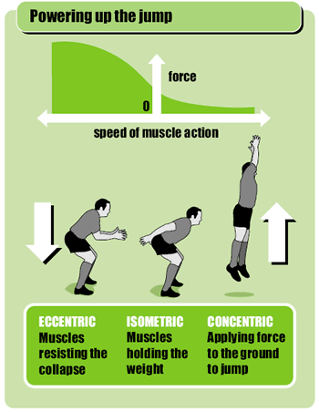

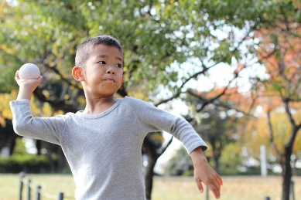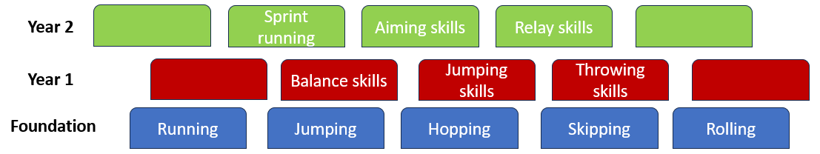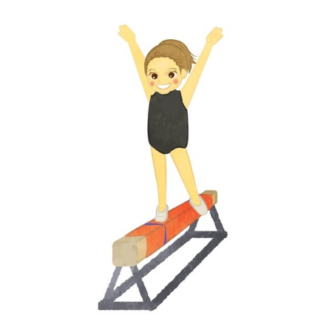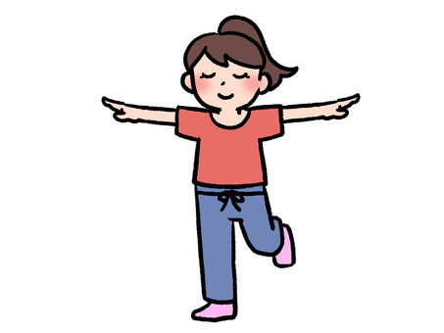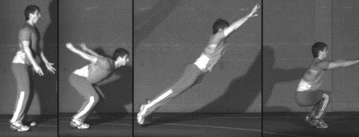

**Throwing**

**Balancing**

**Jumping**